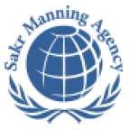 | SAKR MANNING AGENCY  FOR RECRUITING EGYPTIAN LABOR ABROAD | Issue Date | 15.05.2022
 | SAKR MANNING AGENCY  FOR RECRUITING EGYPTIAN LABOR ABROAD | Revision Date | 19.07.2022
 | Crewing Management Manual  Seafarer Employment Application | Revision | 1.1
 | Crewing Management Manual  Seafarer Employment Application | Page | 3
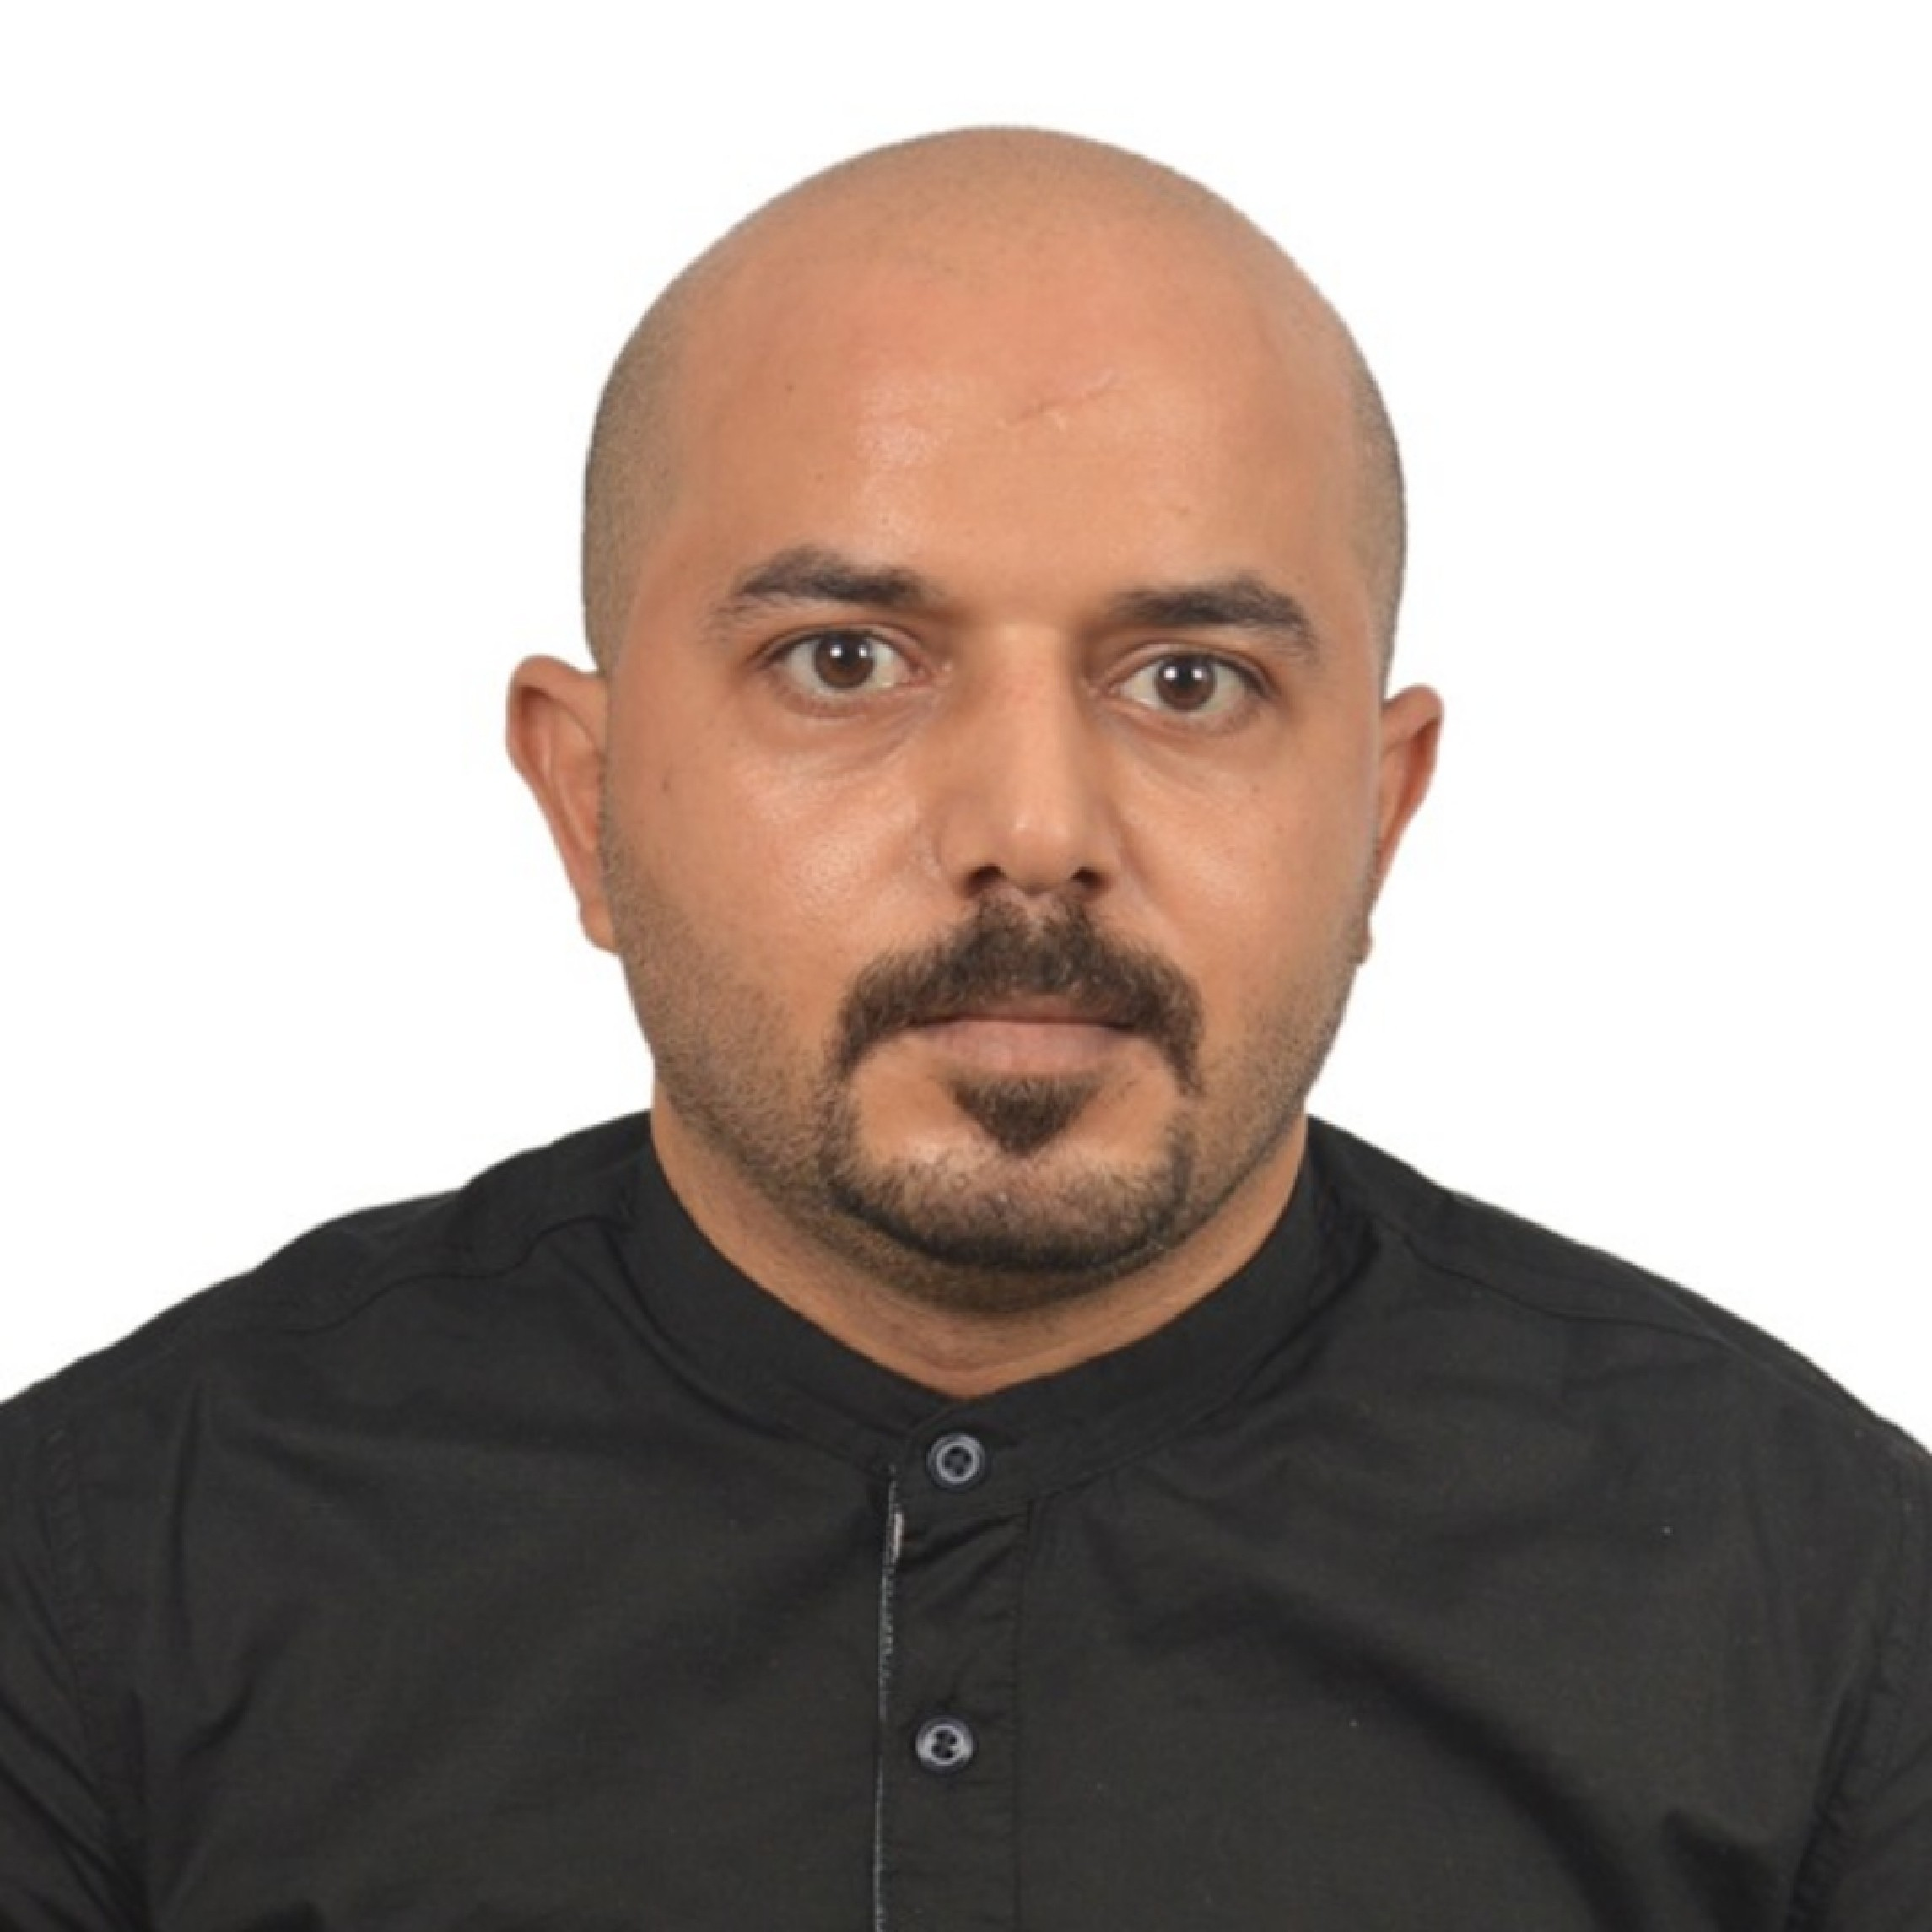
Application For Position as | Oiler
Register Code. | ER-3.072
Other Position (If Any) | Wiper
Register Date | 14/05/2023
Last up Date Data | 20/4/2023
Expected Salary | $800 is possible, more or less

1. PERSONAL DETAILS
Full Name |  | AMR ABD ALLAH MOHAMED ELFIKY
Date Of Birth |  | 21/11/1987 |  |  |  |  |  |  | Place Of Birth |  |  |  |  |  |  |  | Alexandria
Nationality |  | Egyptian |  |  |  |  |  |  | Marital Status |  |  |  |  |  |  |  | Single |  |  |  |  |  |  |  | Married yes
Height (Cm) |  | 162 c.m |  |  |  |  |  |  | Overall Size |  |  |  |  |  |  |  | L |  |  |  |  | Shirt Size |  |  |  |  |  | Larg
Weight (Kg) |  | 72 k.g |  |  |  |  |  |  | Trouser Size |  |  |  |  |  |  |  | 33 |  |  |  |  | Shoes Size |  |  |  |  |  | 40
2. EDUCATION
College / School |  | Industrial secondary school three-year system
Marline Test |  | Issued Date |  |  |  |  | Result % |  |  |  | Issued By (Authority) |  |  |  |  |  |  |  |  |  | Issued At
 |  | 2006 |  |  |  |  | 85% |  |  |  | 2003 |  |  |  |  |  |  |  |  |  | 2006
English Language |  | Fluent |  |  |  |  |  | Good yes |  |  |  |  | Average |  |  |  |  |  |  |  | Poor
……… Language  ( ) |  | Fluent |  |  |  |  |  | Good |  |  |  |  | Average |  |  |  |  |  |  |  | Poor
3. CONTACT DETAILS
Home Address / City |  |  | 17 st Elayoun Ghaet Elaneb Karmos of Alexandria Alexandria
E-Mail |  |  | elfikyamr16@gmail.com |  |  |  |  |  |  | Mobile / Tel |  |  |  |  |  | 01122934587

4. TRAVEL DOCUMENTS
Type |  | Document No. |  |  |  | ISS. Date |  |  | Exp. Date |  |  |  |  | ISS. By (Authority) |  |  |  |  |  |  |  |  |  | Place of Issue
Passport |  | A2842060 |  |  |  | 26/7/2021 |  |  | 25/72028 |  |  |  |  | Egyptian Authority |  |  |  |  |  |  |  |  |  | Alex
Seaman Book |  | S00026937 |  |  |  | 17/11/2022 |  |  | 14/11/2027 |  |  |  |  | EAMS |  |  |  |  |  |  |  |  |  | Alex.
Other Seaman Book

5. PROFESSIONAL QUALIFICATION / CERTIFICATE OF COMPETENCY
Certificate Name |  |  |  |  | Number | Issue Date |  |  |  |  |  | Expiry Date |  |  |  |  |  | Issued By |  |  |  |  |  |  |  |  | Issued At
COC |  |  |  |  |  |  |  |  |  |  |  |  |  |  |  |  |  | EAMS |  |  |  |  |  |  |  |  | Alex.
GOC |  |  |  |  |  |  |  |  |  |  |  |  |  |  |  |  |  | NTRA |  |  |  |  |  |  |  |  | Cairo
D.P. INDUCTION
D.P. ADVANCED
D.P. OPERATOR (UNLIMITED)
6. NEXT OF KIN
Full Name | Ahmed abd allah mohamed |  |  |  |  |  |  |  |  |  |  |  |  |  | Relationship |  |  |  |  | Brother
Address | 17st Elayon Ghayt Elaneb Karmos Of Alexandria
Tel. No. |  |  |  |  |  |  |  |  |  | Mobile |  |  | 01113703500
7. HEALTH CERTIFICATES & VACCINATIONS
Flag State |  |  |  | Number |  |  | Issue Date |  |  |  |  | Expiry Date |  |  |  |  |  |  | Issued By |  |  |  |  |  |  | Issued At
International Medical |  |  |  |  |  |  | 29/11/2022 |  |  |  |  | 28/11/2024 |  |  |  |  |  |  | EAMS |  |  |  |  |  |  | Alex.
Yellow Fever |  |  |  |  |  |  |  |  |  |  |  |  |  |  |  |  |  |  | Ministry of Health
Cholera |  |  |  |  |  |  |  |  |  |  |  |  |  |  |  |  |  |  | Ministry of Health
Covid-19 |  |  |  | Vaccination Name |  |  | First Dose |  |  |  |  | Second Dose |  |  |  |  |  |  | (Other Does or Remarks)
 |  |  |  | Pfizer |  |  | 10/11/2021 |  |  |  |  | 15/12/2022

8. MARINE COURSES
Course Name | Number | Issue Date | Expiry Date | Issue8d By / At
Personal Survival Techniques | 39175/22/EG | 29/12/2022 | 14/12/2027 | AASTMT
Proficiency In Personal Survival Techniques
Fire Prevention and Fire Fighting
Advanced Fire Prevention and Fire Fighting | 39175/22/EG | 29/12/2022 | 14/12/2027 | AASTMT
Elementary First Aid | 39175/22/EG | 29/12/2022 | 14/12/2027 | AASTMT
Medical Care Studies
Personal Safety and Social Responsibilities | 39175/22/EG | 29/12/2022 | 14/12/2027 | AASTMT
Proficiency Of Security Awareness Training Seafarers | 39425/22/EG | 20/12/2022 | 18/12/2027 | AASTMT
Proficiency as a ship Security officer ( PSSO )
Proficiency In Survival Craft & Rescue Boats
G.M.D.S.S
Communications
Advanced Communications
ECDIS Advanced Simulator (Management Level)
ECDIS Simulator (Operation Level)
Prevention and Combating of Marine Pollution
Radar & ARPA Simulator and Search &rescue
ARPA Simulator and Search
Marine Radar and automatic Radar Plotting
Bridge resource Management (B.R.M)
Engine resource Management (E.R.M)
Navigational Watch keeping
Proficiency for Rating forming part of Navigational watch (II/4) |  |  |  | EAMS / Alex.
High voltage training – operation of ship (1000 Volt and More)
Passenger Safety Cargo Safety and Hull integrity
Crowd Management Training
Crisis Management and Human Behavior Training
Safety training for Personal Prov. Direct Passengers
Practical Ability to Prepare Meals and (MLC 2006)
Personal Hygiene and Envir. Protection (MLC 2006)
Safety and Health in the Provision Meals (MLC 2006)
Food Storage and inventory Control (MLC 2006)
Ships Cook Certificate (MLC 2006) |  |  |  | EAMS / Alex.
Abel Seafarer Deck
Proficiency for Abel Seafarer Deck ( II/5 ) |  |  |  | EAMS / Alex.
Engineering Watch keeping |  |  |  | EAMS / Alex.
Proficiency for Rating forming part of a watch in engine room
Abel Seafarer Engine
Proficiency for Abel Seafarer Engine ( III/5 ) |  |  |  | EAMS / Alex.
Electro Technical Rating
Proficiency for Electro Technical rating ( III/7 ) |  |  |  | EAMS / Alex.

COMPLETE SEA – SERVICE DETAILS

Name: |  |  |  |  |  |  |  | Rank: |  |  |  |  |  |  |  | Register Code:
Company Name |  |  | Rank |  | Vessel Name |  |  |  | Signed On |  |  | Signed Off |  |  |  | Period |  |  | Vessel Type |  | D.W.T. |  |  |  |  | Engine Type |  |  | BH | KW
El zaki for repair |  |  | Assistant mechanic |  | Shrok 1 |  |  |  | 4/3/2023 |  |  | 20/4/2023 |  |  |  |  |  |  | General cargo |  |  |  |  |  |  | Caterpillar 800 HP |  |  |  | 400
SPECIALISED EXPERIENCE
Name |  |  |  |  |  |  |  |  |  | Type |  |  |  | From |  |  | To |  |  |  |  | Comments
The Egyptian Company for Ship Repair and Building |  |  |  |  |  |  |  |  |  | Mechanical installation technician |  |  |  | 1/7/2009 |  |  | 1/10/2016 |  |  |  |  | I worked in it for 7 years. I do maintenance of all collars and sea louvers, install pipes, and do straightening machines together with the suction column.
Mabso for supplies and marine equipment |  |  |  |  |  |  |  |  |  | Mechanicl  Installation  Technical |  |  |  | 1/11/2016 |  |  | 1/12/2022 |  |  |  |  | The company worked together in building fast launches and straightening engines from A. Z
Vse logistics American com | General service | 1/1/2021 | 30/9/2022 | The company worked together to overhaul Caterpillar Model No. 3512c engines and lifetimes of Scania generators and lifetimes of Scania machines
eclare that the information I have given is, to the best of my knowledge, true and complete. I also declare that the documents submitted are genuine, given and sign by persons whose names appear on them.
 |  |  |  |  |  |  |  |  |  |  |  |  |  |  | DATE |  |  |  |  |  |  |  |  |  | SIGNATURE
 |  |  |  |  |  |  |  |  |  |  |  |  |  |  | 20/4/2023 |  |  |  |  |  |  |  |  |  | Amr abd allah Mohamed

